SanDisk Ultra microSDXC UHS-I 128GB Memory Card SDSQUNR-128G-GN6MN

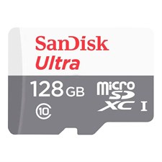

**Key Features:**

* **Capacity**: 128GB, suitable for storing photos, videos, music, and apps.
* **Speed**:
  + **Read Speed**: Up to 100 MB/s, allowing for quick transfer of files to your devices or computer.
  + **Class**: A1 App Performance Class for faster app loading.
* **Compatibility**:
  + Designed for Android™ devices and other microSDXC-compatible devices.
  + Adapter included for compatibility with SD card slots.

**Use Cases:**

* **Smartphones and Tablets**: Expand storage for apps, photos, and videos.
* **Cameras**: Perfect for recording Full HD videos and capturing high-resolution images.
* **Laptops and Gaming Consoles**: Store games, files, and more using the included SD adapter.

**Warranty:**

* Backed by a **10-year limited warranty**, ensuring long-term reliability and support.